DIS Agent API

# Diagram

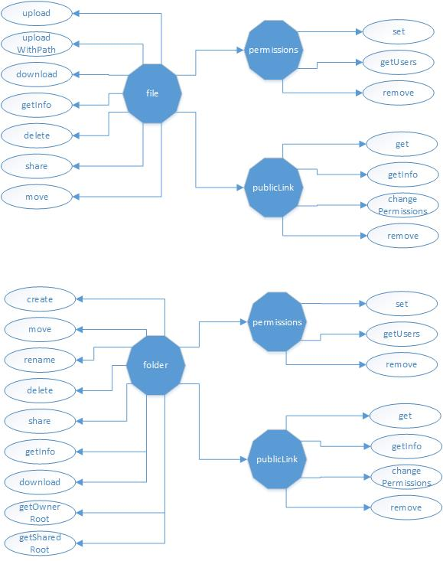

# APIs

## File:

* /file/upload (appKey, accountName, fileContent, parentId, fileName)
* /file/uploadWithPath (appKey, accountName, filePath, parentId, fileName)
* /file/download (appKey, accountName, fileId, path)
* /file/getInfo (appKey, accountName, fileId)
* /file/delete (appKey, accountName, fileId, parentId)
* /file/share (appKey, accountName, fileId, permission, accounts)
* /file/move (appKey, accountName, fileId, parentId, newParentId)
* /file/publicLink/get (appKey, accountName, fileId)
* /file/publicLink/remove (appKey, accountName, fileId)
* /file/publicLink/getInfo/<key> (appKey, accountName)
* /file/publicLink/changePermission (appKey, accountName, fileId, permission)
* /file/permission/getUsers (appKey, accountName, fileId)
* /file/permission/set (appKey, accountName, appKeyShared, accountNameShared, fileId, permission)
* /file/permission/remove (appKey, accountName, appKeyShared, accountNameShared, fileId)

## **Directory**:

* /folder/create (appKey, accountName, folderName, parentId)
* /folder/move (appKey, accountName, folderId, newParentId)
* /folder/rename (appKey, accountName, folderId, folderName)
* /folder/delete (appKey, accountName, folderId)
* /folder/getInfo (appKey, accountName, folderId)
* /folder/download(appKey, accountName, folderId, path)
* /folder/share (appKey, accountName, folderId, permission, accounts)
* /folder/getOwnerRoot (appKey, accountName)
* /folder/getSharedRoot (appKey, accountName)
* /folder/publicLink/get (appKey, accountName, folderId)
* /folder/publicLink/remove (appKey, accountName, folderId)
* /folder/publicLink/getInfo/<key> (appKey, accountName)
* /folder/publicLink/changePermission (appKey, accountName, folderId, permission)
* /folder/permission/getUsers (appKey, accountName, folderId)
* /folder/permission/set (appKey, accountName, appKeyShared, accountNameShared, folderId, permission)
* /folder/permission/remove (appKey, accountName, appKeyShared, accountNameShared, folderId)